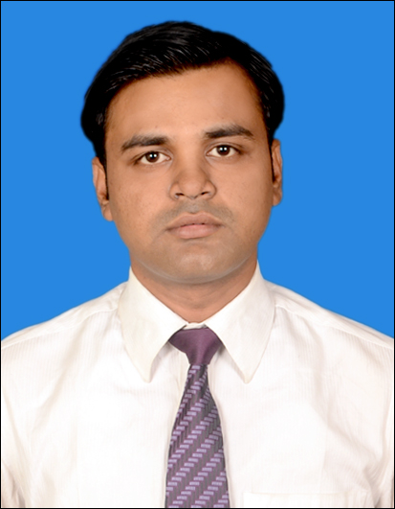
Jyoti Shankar Shaw
Contact No.: +91-8100791194
Email Id : jyotishankarshaw@gmail.com

CAREER OBJECTIVE
A job that enriches my knowledge base and ensures me dignity, motivation, internal satisfaction and upward mobility. I am looking for challenging opportunities in an organization, which provides me the above features and the exposure to various types of work.

QUALIFICATIONS

- Professional

CA Final Nov 2015 54.75% ICAI

CA IPCC Nov 2010 50.71% ICAI
- Academic
M.Com 2012 44.50% University Of Calcutta
B.Com (H) 2010 64.75% University Of Calcutta
10+2 (Com) 2007 57.14% West Bengal Council Of Higher Secondary Education
10th 2005 62.75% West Bengal Board Of SecondaryEducation

IT & OTHER SKILLS
- Certificate in 100 hours Compulsory IT Training Conducted by ICAI
- Well-versed & hands-on experience in MS-Word, Ms-Excel, Tally & Internet
- Successfully completed General Management & Communication Skills from ICAI, Kolkata

WORK EXPERIENCE

Professional Experience (Post-Qualification) :-

Firm : Munshi & Bhattacharya.
Job Location : Kolkata (West Bengal)
Designation : Accounts and Audit Executive
Job Duration : 1st March, 2016 to 31st October, 2016

Job Profile:

- Accounting Service :
Finalization of Financial Statement in compliance with Schedule III of the Companies Act, 2013, Accounting Standards, Standards on Auditing and CARO.

- Auditing and assurance:
Internal Audit, Statutory Audit, Tax Audit, VAT Audit.

- Taxation :
Computation of Income & Income Tax and preparation of Income Tax Return of companies and Individuals.

Pre-Qualification :-

Articleship: Munshi & Bhattacharya : 9th August 2010 to 8th August 2013

Major assignments handled :

- Public Companies :
  - Hindustan Steelwork Construction Limited.
HSCL was established in 1964 as a construction organization under the Ministry of Steel, Govt of India. It diversified into a versatile infrastructure portfolio all over the country.
Areas of Work:
    - Statutory Audit
    - Tax Audit
- Orissa Minerals Development Company Limited
Areas of Work:
    - PF Audit
  - Fairland Development India Limited
Areas of Work:
    - Statutory Audit
    - Tax Audit
  - Private companies:
- Kaizen Electric Equipment Pvt. Ltd.
- A K Enterprises Pvt. Ltd.
- IGT Aero Travels Pvt. Ltd
- Unitech Water Technologies Pvt. Ltd.
- Unitech Environmental Services Pvt. Ltd
- Tycoons Industries Pvt Ltd.
Areas of Work:
    - Statutory / Internal Audit
    - Tax Audit
    - Filing of ROC Returns, drafting of minutes etc.
    - Professional assistance in Finalisation of Accounts, TDS & other I.Tax matters
    - Assistance in Service Tax & Sales Tax matters

HOBBIES

Listening to music, travelling, watching movie and cricket

PERSONAL PROFILE
Sex : Male
Date of Birth : May 16, 1988
Marital Status : Single
Languages known : Hindi, English and Bengali
Address : Chandni Block
49/1 S.N.Banerjee Road
Kolkata – 700014

Date:
Place: (Jyoti Shankar Shaw)

